Hello, I am VelanoGD and I will introduce you to my newest expose.
Today’s exposed person is… SOLARWALKERGD. Yes, I’ve never done this, but it’s time.
So let’s stop yapping and START.
Expose #1
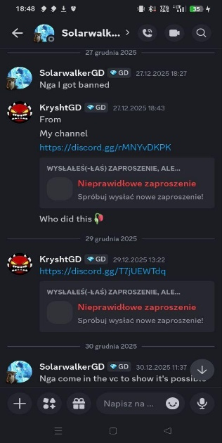
SolarwalkerGD saying n****
Yes, he did say it and he says to my friend Krysht that he is racist, meanwhile he says racial slurs and adds that his pronouns in discord is racista/racist. One time I saw on his bio that he wrote racial slurs too but didn’t screenshot it.
Expose #2
Fake GD Stats
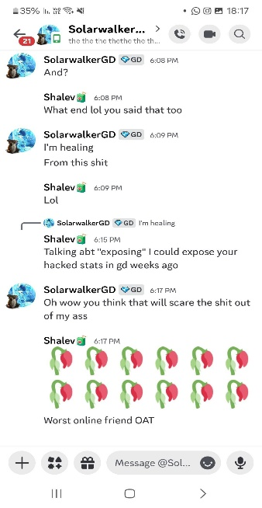
That’s all for now. I will show more screenshots later. Goodbye!

